Its assumed that in all cases, the user has seen the show, and has some knowledge of location, possessions and know some of the story.

Case Scenario 1:

Shae started to watch Game of Thrones after taking a break from it. He sees this woman he knows is pivotal to the story but doesn’t remember her name. He knows that she is in Essos, but she didn’t originally belong from Essos because that was established at the start of the show. Below is the test scenario: 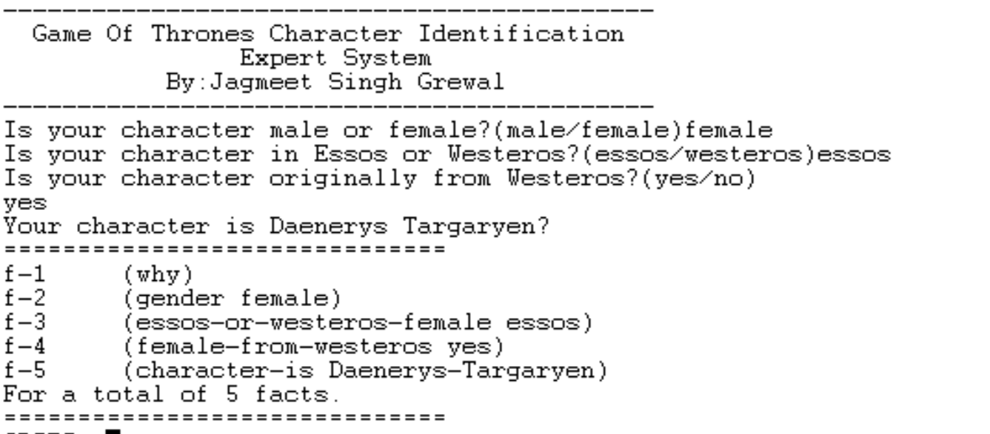

Case Scenario 2:

Shae Bunge remembers that there was a character from Game of Thrones that was with Daenerys that lives in Essos. Shae also remembers that she was not one of Daenerys’s servants, but he doesn’t remember her name. He wants to know more information about her online but needs to know her name. Shae has watched Game of Thrones before that’s why he remembers this information. 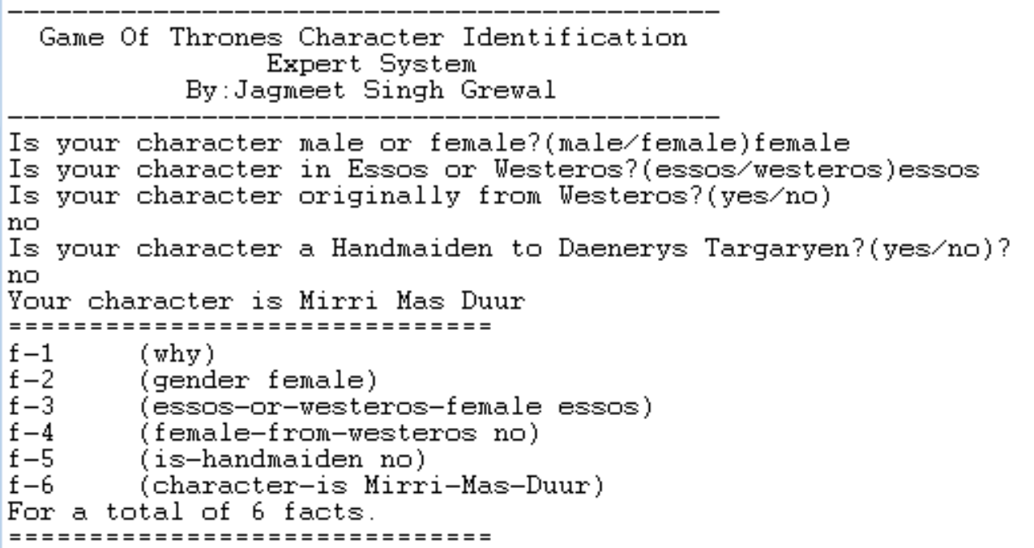

Case Scenario 3:

Shae also remembers that the witch (which Shae knows that is Mirri Mas Duur) killed Daenerys’s husband. He knows that her husband lives in Essos and is a Dothraki because that was mentioned a lot when Daenerys was first married to him.

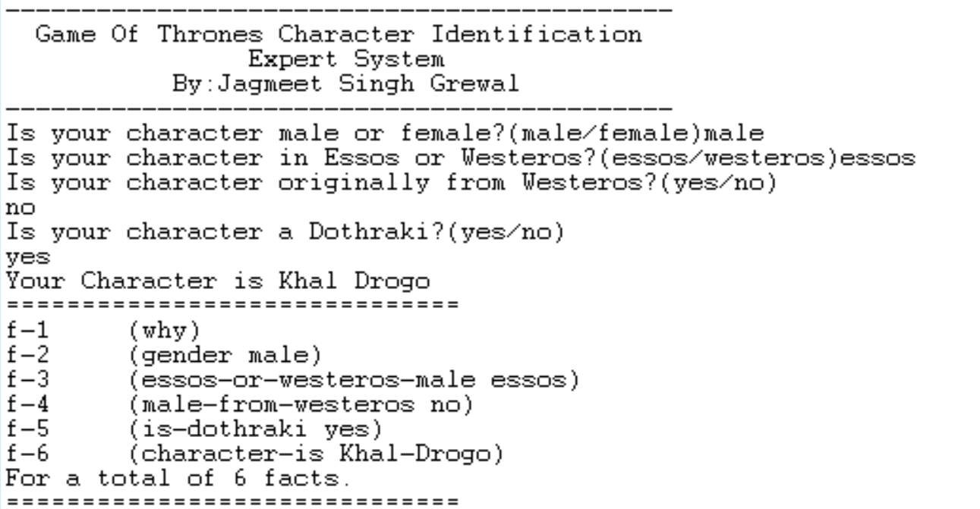

Case Scenario 4:

Tim was online and looking at a meme his friend tagged him in. He recognises the face but doesn’t full remember who this person was. He knows this person is from the North, which is in Westeros and remembers that he was the one who executed the man who ran from the Wall in the very first episode with a very big sword. Without knowing the person, he is unable to understand the meme and thus can’t relate with this friend. He uses the expert system to determine the character.

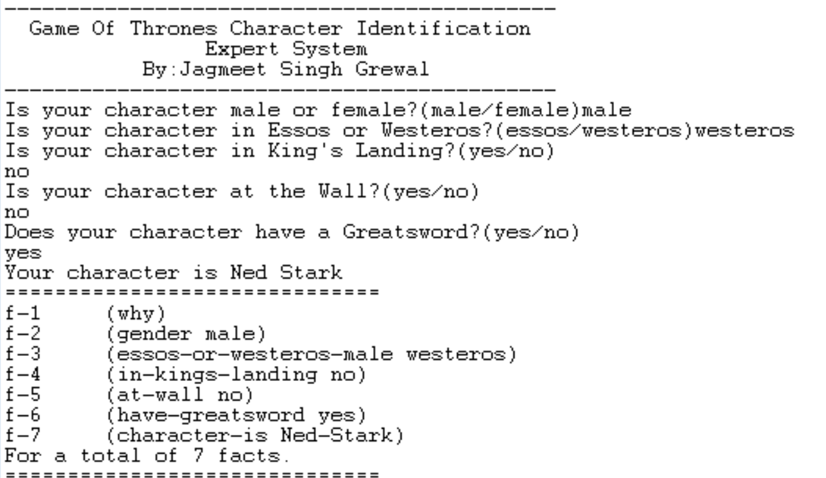

Case Scenario 5:

A group of friends were discussing the scene were a person had molten gold poured over their head. Jagmeet doesn’t remember why this person is significant, he wants to look him up but doesn’t remember his first name. He knows of an expert system that can help identify him and give vital information about this character at the end (this feature is added in the actual system). He remembers that this character is in Essos but is originally from Westeros because this character has mentioned of going back to Westeros, implying that he is from there. He also remembers that this character has white hair which was quite uncommon. 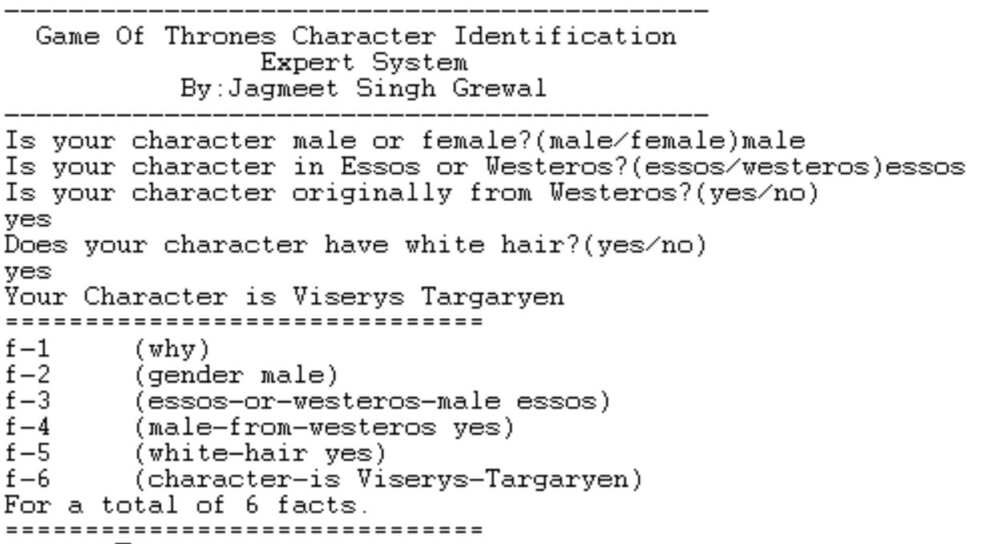

Case Scenario 6:

On an online discussion, a group of people were discussing Robert Baratheon from Game of Thrones. Jagmeet thinks he knows who this Robert is but wants to confirm. So, he uses the Expert System to know if the person he is thinking of is Robert. Jagmeet knows that the person he is thinking of is a part of the royal family which lives the King’s Landing, which is the capital of Westeros. He has an idea of what the person, he is thinking of, looks like. 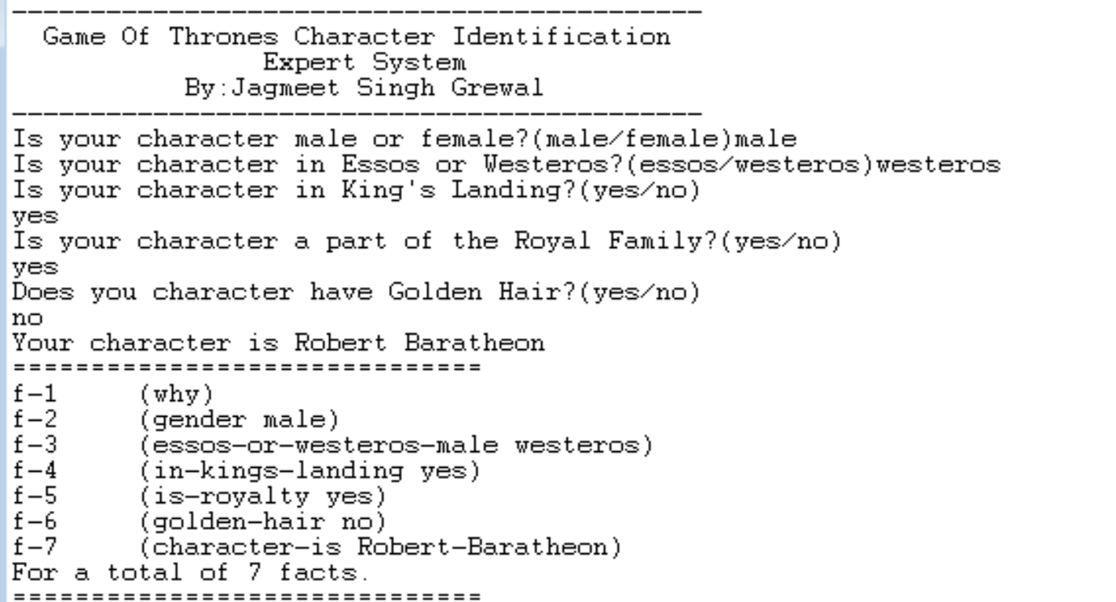

Case Scenario 7:

A group of friends are trying to figure out who this one character is but none of them can remember what her name is. They know that she is a Lady to a great house. They open up the expert system and go through the prompts. Once they get to the question “Is your character in the North?” They answer no because they know that her sister brought Tyrion to her castle, which was not in the North. They continue through the questions and here is there conclusion. The system shows the image of this person and they confirm that this was the person that they were thinking about. 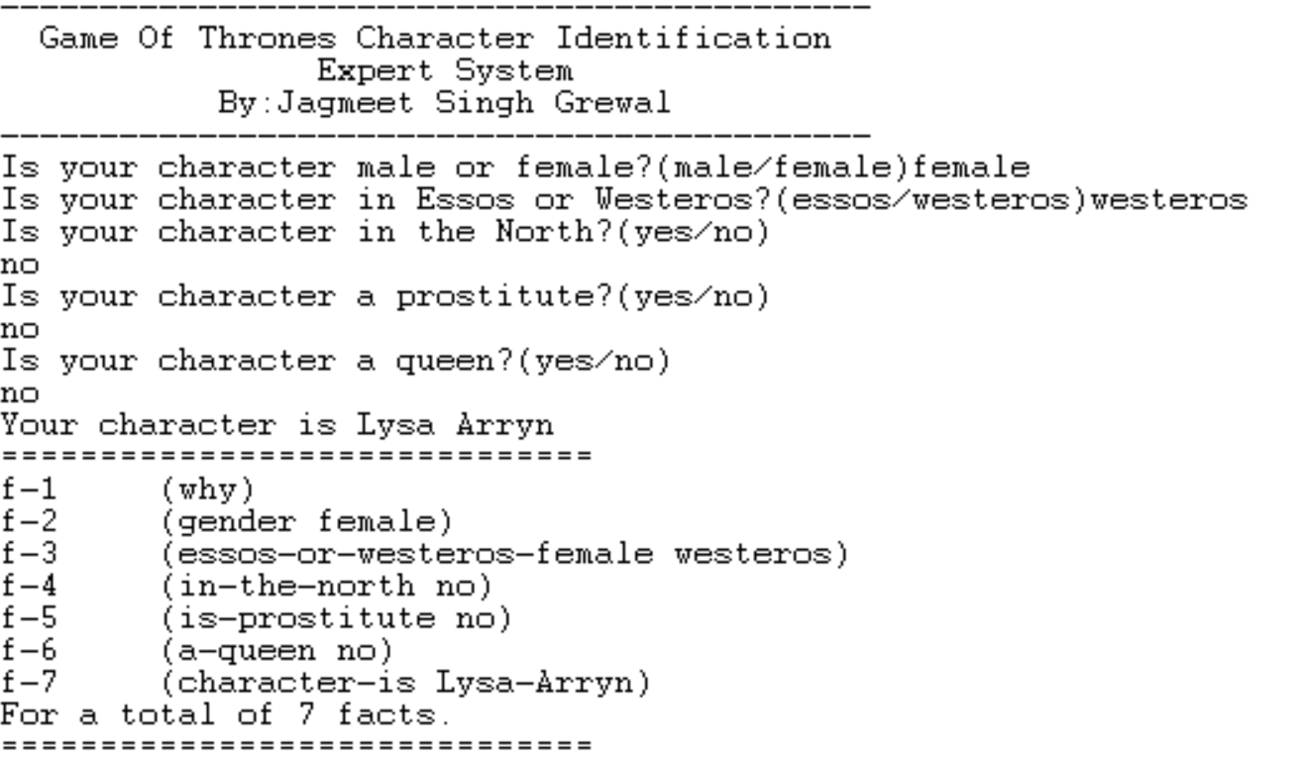

Case Scenario 8:

Danyal is trying to remember which one of the Stark sisters is which because his friends are talking about one and wants to know who they are referring to. He knows that they are in the North in Winterfell. He opens the expert system and goes through the questions until he gets to the question, “Does your character have red hair?”, he knows that one of them does have red hair and knows what see looks like. He continues and reaches a conclusion. The system shows an image of Sansa. Now he can distinguish between the sisters and now join with the discussion with his friends. 